Wellness Autopilot

Environmental Wellness

Environmental Wellness

#1
Title
Make Your Home Healthier

Message
Take a look around your home. Do you know what’s in your household goods and products? Some chemicals can harm your health if too much gets into your body. Becoming aware of potentially harmful substances and clearing them out can help keep you and your family healthy.

To reduce potential toxins in your home:
1. Clean with “Safer Choice” or non-toxic products.
2. Dust using a damp rag.
3. Use a wet mop to clean floors.
4. Vacuum with a high-efficiency particulate air (HEPA) filter.
5. Open a window or use a fan to improve air circulation when you’re cleaning.
6. Have and maintain a good ventilation system in your home.
7. Wash your hands and your children’s hands often.

Link
https://newsinhealth.nih.gov/2016/12/making-healthier-home

Image

#2
Title
Reduce Your Allergies

Message
A change in season can brighten your days with vibrant new colors. But blooming flowers and falling leaves can usher in more than beautiful backdrops. Airborne substances that irritate your nose can blow in with the weather.

Take steps to reduce your exposure to allergens:
1. Avoid outdoor allergens whenever possible. If pollen counts are high, stay inside with the windows closed and use the air conditioning.
2. Avoid bringing pollen indoors. If you go outside, wash your hair and clothing when you come inside.
3. Pets can also bring in pollen, so clean them too.
4. Reduce indoor allergens. Keep humidity levels low in the home to keep dust mites and mold under control.
5. Avoid upholstered furniture and carpets because they harbor allergens.
6. Wash your bedding in hot water once a week.
7. Vacuum the floors once a week.
8. Talk with your doctor about medications and allergy shots.

Link
https://newsinhealth.nih.gov/2016/06/seeking-allergy-relief

Image
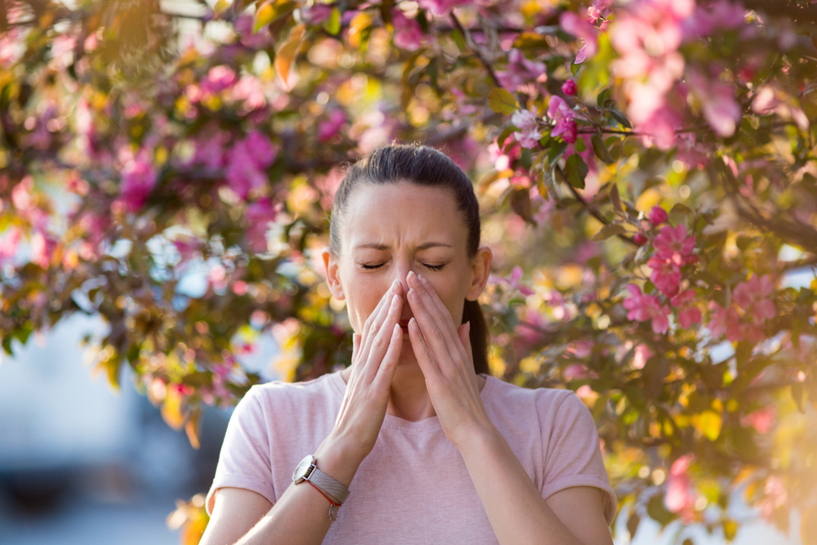

#3
Title
Stay Safe During Hot Weather

Message
Heat is the biggest danger in the summer months. Being hot for too long can cause many illnesses, some of which can be deadly.

To create healthy summer habits:
1. Do outdoor activities during the coolest part of the day, in the early morning or evening.
2. Wear protective clothing, such as hats, long-sleeve shirts, and long pants or skirts to block out the sun’s harmful rays.
3. Use sunscreen that blocks both UVA and UVB with a sun protection factor (SPF) of at least 15, preferably 30. Reapply frequently.
4. Use sunglasses that block both UVA and UVB.
5. Try to stay in the shade when outdoors during peak sunlight.
6. Exercise in an air-conditioned space if possible. Or do water workouts.
7. Drink plenty of liquids, especially water. Avoid drinks that contain alcohol or caffeine.

Link
https://newsinhealth.nih.gov/2021/06/beat-heat

Image

#4
Title
Guard against Cold Weather

Message
The frosty air of winter can be invigorating. But cold air can also pose threats to your health, whether you’re indoors or outside. Learn to recognize the signs of your body temperature dropping too low, and take steps to keep yourself and your family warm and safe during the chilly season.

To guard against the cold:
1. Dress in layers.
2. Cover up with blankets.
3. If you expect to be out in the wind, rain, or snow, wear a jacket with a waterproof and windproof outer shell.
4. To keep warm at home, wear socks, slippers, and a cap or hat.
5. Set your heat at 68° or higher when it’s cold outside. To save on heating bills, close off rooms you’re not using.
6. If you need help paying your home heating bills, you may qualify for an energy assistance program.
7. If you suspect that someone you know or love may be at risk of hypothermia, take quick action to warm them up with blankets and warm drinks, but avoid hot-water baths and heating pads.

Link
https://newsinhealth.nih.gov/2015/12/halting-hypothermia

Image
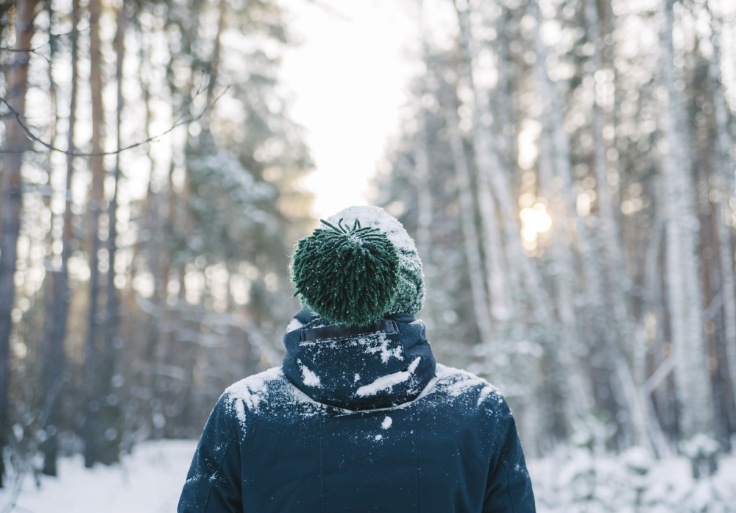

#5
Title
Air Quality and Your Health

Message
The combination of high temperatures, pollution, and airborne particles can brew up an unhealthful mixture in the air, just waiting to enter your lungs. This can make it hard to breathe and sap your energy.

To reduce the effects of poor quality air on your health:
1. Avoid outdoor activities in the afternoons on warmer days, when the risk of air pollution is highest.
2. Avoid strenuous outdoor activities if the air is polluted.
3. Reduce pollutants in your home. Don’t let anyone smoke in your home. Avoid burning candles, incense, or wood fires. Run fans or open a window when cooking. Use a vacuum with a HEPA filter instead of sweeping to avoid stirring up dust and allergens.

Link
https://newsinhealth.nih.gov/2018/09/breathe-easier

Image

#6
Title
Stay Safe in the Water

Message
Summer is a great time to go out and have fun in the water. But recreational waters—including swimming pools, lakes, and oceans—can sometimes get contaminated with bacteria and viruses.

To stay safer while playing in the water:
1. Shower before and after swimming.
2. Try not to swallow the water.
3. Never go to the bathroom in the water. Take kids for bathroom breaks and check diapers every hour.
4. Change diapers away from the water.
5. Stay out of the water if you’ve had diarrhea recently to help protect others from infectious germs.
6. Always wash your hands before you eat or drink.
7. Cover open wounds with waterproof bandages.
8. Don’t swim in water that looks murky or has an odor.
9. Stay out of the ocean for at least 24 hours after a storm. Avoid places where storm water is released on the beach.
10. Check for warning signs posted around the area. Ask lifeguards about the water conditions.
11. Check local alert systems.

Link
https://newsinhealth.nih.gov/2022/06/staying-safe-water

Image

#7
Title
Clear out Toxins in Your Home

Message
Some hazards in the home are easy to see. Like a loose electrical socket. Or torn carpet on the stairs. But others are harder to spot. And some are invisible, in the very air you breathe. These include lead, mold, and radon. But there are ways you can find and fix these unseen hazards.

To reduce health hazards in your home:
1. If your home was built before 1978, test exposed paint for lead. You can buy test kits yourself or hire a professional. Some city health departments provide free test kits.
2. Have children tested for lead exposure regularly, from at least birth through age six.
3. Use vent fans in rooms that have lots of moisture, like the bathroom, to prevent mold growth.
4. If you have a leak or flood in your home, quickly dispose of damaged items.
5. Clean small areas of mold on walls or fabric with hot, soapy water. Be sure to wear a mask, gloves, and goggles while cleaning.
6. Test your home for radon. Some local, county, or state programs offer free test kits.

Link
https://newsinhealth.nih.gov/2022/05/hidden-hazards

Image

