Wellness Autopilot

Disease Prevention

Disease Prevention

#1
Title
Get Screened for Diseases

Message
Some screenings can reduce your risk of dying from a disease. But sometimes, experts say, a test may cause more harm than good. Before you get a test, talk with your doctor about the possible benefits and harms to help you decide what’s best for your health.

To learn about screening tests, ask your doctor:
1. What’s my chance of dying of the condition if I do or don’t have the screening?
2. What are the harms of the test? How often do they occur?
3. How likely are false positive or false negative results?
4. What are possible harms of the diagnostic tests if I get a positive screening result?
5. What’s the chance of finding a disease that woudn’t have caused a problem?
6. How effective are the treatment options?
7. Am I healthy enough to take the therapy if you discover a disease?
8. What are other ways to decrease my risk of dying of this condition? How effective are they?

Link
https://newsinhealth.nih.gov/2017/03/screen-or-not-screen

Image

#2
Title
Guard against Germs

Message
For nearly a century, bacteria-fighting drugs known as antibiotics have helped to control and destroy many of the harmful bacteria that can make us sick. But these drugs don’t work at all against viruses, such as those that cause colds or flu. Learn how to protect yourself against germs in the environment.

To block harmful germs:
1. Wash your hands often with soap and water, or use an alcohol-based hand sanitizer.
2. If you’re sick, make sure your doctor has a clear understanding of your symptoms. Discuss whether an antibiotic or a different type of treatment is appropriate for your illness.
3. If antibiotics are needed, take the full course exactly as directed. Don’t save the medicine for a future illness, and don’t share with others.
4. Maintain a healthy lifestyle—including proper diet, exercise, and good hygiene—to help prevent illness, thereby helping to prevent the overuse or misuse of medications.

Link
https://newsinhealth.nih.gov/2014/02/stop-spread-superbugs

Image
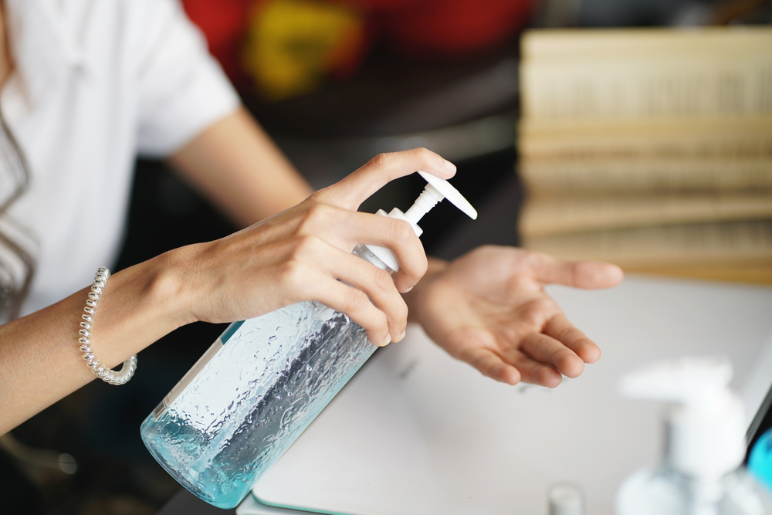

#3
Title
Protect Your Body’s Bacteria

Message
Microscopic creatures—including bacteria, fungi, and viruses—can make you ill. But what you may not realize is that trillions of microbes are living in and on your body. Most don’t harm you at all. We tend to focus on destroying bad microbes. But taking care of good ones maybe even more important.

To protect good microbes:
1. Eat a diet high in fiber. Fiber is found in plants, including fruits, vegetables, and whole grains.
2. Limit foods that can hurt your gut microbes. These include sugar and fatty or highly processed foods.
3. Know when to wash your hands, like when preparing food, before eating, or after handling pets or garbage.
4. Use hand sanitizer when you can’t use soap. Be sure it contains at least 60% alcohol.
5. Avoid antibacterial soaps and other products. These can harm the protective microbes on your skin.
6. Be wary of “probiotics.” These products can be food or supplements. They may claim to restore a healthy microbe mix, but many have not been properly studied.

Link
https://newsinhealth.nih.gov/2021/08/your-bodys-bugs

Image
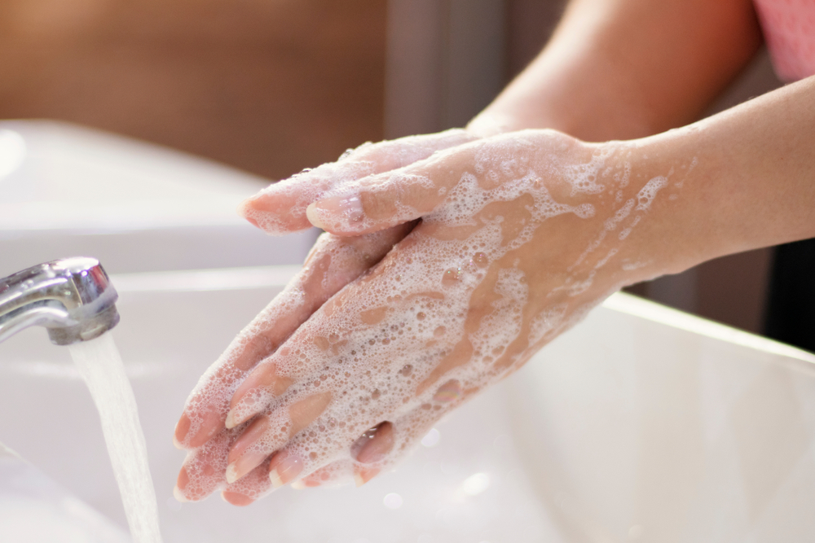

#4
Title
Block Tick Bites and Lyme Disease

Message
When warm weather arrives, you might get the urge to walk barefoot through the grass. But before you stroll through your lawn or head out on a hiking trail, you’ll want to protect yourself and your loved ones from ticks that often lurk in tall grass, thick brush, or wooded areas.

To prevent tick bites or tick-borne diseases:
1. Help keep ticks off your skin by wearing long sleeves, long pants, and long socks.
2. Ward off ticks by using an insect repellant that contains at least 20% DEET (for the skin) or permethrin (for clothes).
3. Avoid ticks by walking in the center of trails and steer clear of tall vegetation.
4. If you’ve been in an area where ticks are common, bathe or shower as soon as possible, and wash or tumble your clothes in a dryer on high heat.
5. Check your body carefully for ticks. They dig and burrow into the skin before they bite and feed.
6. Removing ticks right away can help prevent disease.
7. If you develop a rash or fever after removing a tick, see your doctor.

Link
https://newsinhealth.nih.gov/2014/05/tick-talk

Image

#5
Title
Prevent Mosquito-Borne Illnesses

Message
Most mosquito bites are relatively harmless. The itchy bumps often last for just a day or two after a mosquito has punctured your skin. But if the mosquito is carrying certain germs, like viruses or parasites, these pathogens might enter your blood during the bite and make you sick.

To avoid mosquito bites:
1. Use insect repellents. Products containing DEET, picaridin, lemon eucalyptus, para-menthane-diol, or IR3535 can be applied to skin. Follow label instructions.
2. Cover up. When outside, wear long sleeves, pants, and socks. Mosquitoes may bite through thin fabric, so spray thin clothes with an EPA-registered repellent like permethrin. Don’t apply permethrin directly to skin.
3. Mosquito-proof your home. Install or repair screens on windows and doors to keep insects out. Use air conditioning if you have it.
4. Get rid of mosquito breeding sites. Empty standing water from flowerpots, gutters, buckets, pool covers, pet water dishes, and birdbaths on a regular basis.

Link
https://newsinhealth.nih.gov/2016/04/block-buzzing-bites-bumps

Image

#6
Title
Protect Yourself and Everyone Else from Disease

Message
We share more than food and culture within our homes and communities. We can also spread disease. Luckily, we live in a time when vaccines can protect us from many of the most serious illnesses. Staying current on your shots helps you—and your neighbors—avoid getting and spreading disease.

To protect yourself and others from preventable diseases, stay up-to-date on shots for these 13 vaccine-preventable diseases:
1. Bacterial meningitis
2. Chickenpox
3. Diphtheria
4. Haemophilus influenzae type b
5. Hepatitis A and Hepatitis B
6. Cervical & other cancers caused by human papillomavirus (HPV)
7. Influenza (flu)
8. Measles, Mumps, and Rubella
9. Pertussis (whooping cough)
10. Pneumococcal pneumonia
11. Rotavirus diarrhea
12. Shingles
13. Tetanus

Link
https://www.cdc.gov/vaccines/schedules/easy-to-read/child-easyread.html#vpd

Image
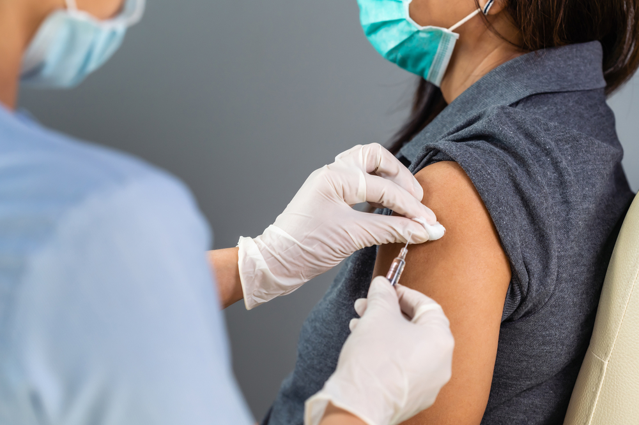

#7
Title
Healthy Choices to Reduce Your Cancer Risk

Message
There are many lifestyle choices you can make to reduce your risk of developing cancer. Here are some tips to keep in mind:

1. Maintain a healthy weight. Aim to maintain a healthy weight through a balanced diet and regular exercise.

2. Quit smoking. Smoking is the leading cause of lung cancer, as well as many other types of cancer.

3. Limit alcohol consumption. Alcohol use has been linked to an increased risk of many types of cancer.

4. Protect yourself from the sun: Exposure to ultraviolet (UV) rays from the sun or tanning beds can increase your risk of skin cancer. Protect your skin by wearing protective clothing and using sunscreen with at least SPF 30.

5. Get vaccinated: Certain viruses, such as human papillomavirus (HPV) and hepatitis B, can increase your risk of developing cancer.

Link
https://www.cdc.gov/cancer/dcpc/prevention/other.htm

Image
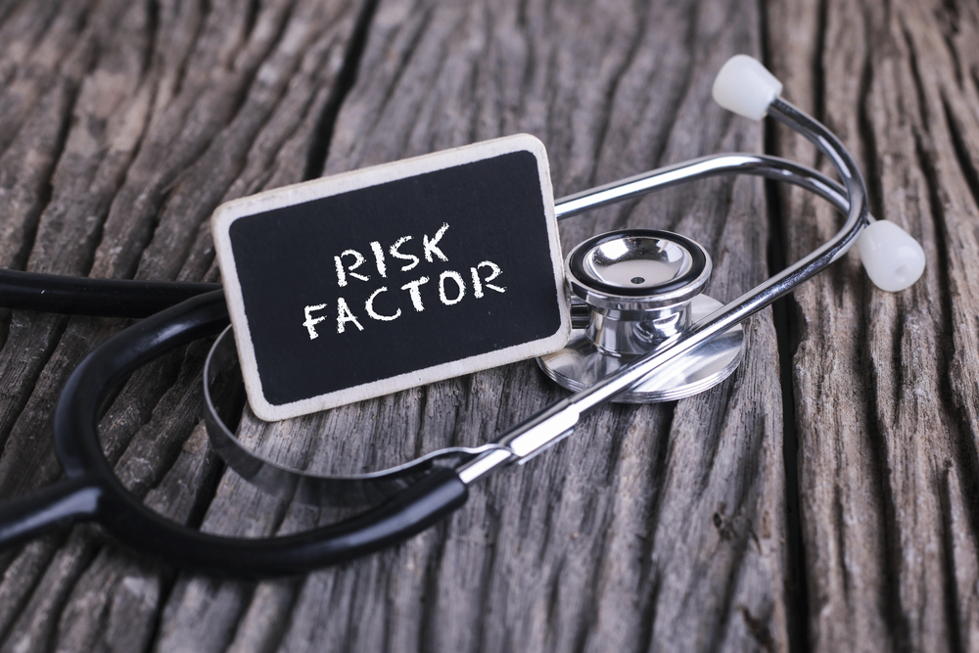

#8
Title
Healthy and Delicious Recipes for a Heart-Healthy Diet

Message
Looking for heart-healthy recipes? Check out Million Hearts for delicious meal ideas that are good for your heart. From breakfast to dinner, their recipe collection offers tasty options that can help you lower your risk of heart disease. Eating well has never tasted so good! Here are some of our favorites:

1. Lemon-Garlic Shrimp and Grits: This flavorful dish is a twist on a Southern classic, made with succulent shrimp, creamy grits, and plenty of herbs and spices.

2. Stuffed Bell Peppers: These colorful peppers are filled with a hearty mixture of ground turkey, quinoa, and vegetables, and are topped with a sprinkle of cheese.

3. Salmon with Avocado Salsa: This simple yet elegant dish features fresh salmon fillets topped with a zesty avocado salsa.

4. Veggie-Packed Pasta Salad: This colorful salad is packed with fiber-rich vegetables like bell peppers, tomatoes, and cucumbers, and is dressed with a tangy vinaigrette.

Link
https://millionhearts.hhs.gov/learn-prevent/recipes.html

Image

