

Wellness Autopilot

Emotional Wellness

Emotional Wellness

#1
Title
Develop Healthy Physical Habits to Build Resilience

Message
Resilience is an important trait that can help you overcome challenges and bounce back from difficult situations. One of the keys to building resilience is to focus on your emotional well-being. Experts recommend developing healthy habits such as regular exercise, eating a balanced diet, and getting enough sleep to improve your physical and mental health.

In addition to taking care of yourself physically, it's important to learn healthy ways to cope with stress and draw from resources in your community. This can include things like talking to a trusted friend or family member, seeking support from a mental health professional, or participating in activities that bring you joy and fulfillment.

Remember, building resilience takes time and practice. By focusing on your emotional well-being and developing healthy habits, you can cultivate the resilience you need to overcome any obstacle that comes your way.

Link

Image


#2
Title
Take Time for Yourself Each Day! Notice the Good Moments! Do Something You Enjoy!

Message
In the midst of our busy lives, it's important to take a moment for ourselves each day. Whether it's 10 minutes or an hour, finding time to recharge and do something enjoyable can have a positive impact on our overall well-being. Taking a walk, reading a book, or listening to music are just a few examples of ways to relax and unwind.

It's also important to take notice of the good moments throughout the day, no matter how small they may seem. This can be as simple as enjoying a cup of coffee or tea in the morning, or having a conversation with a friend or loved one. By focusing on these positive moments, we can shift our mindset to one of gratitude and appreciation.

Remember, taking care of ourselves should be a priority. By incorporating small moments of self-care into our daily routine, we can improve our mental and emotional health and build resilience for the challenges that come our way.

Link

Image


#3
Title
Cultivate Gratitude and Mindfulness for Better Health

Message
Practicing gratitude and mindfulness can help you feel more positive, reduce stress and anxiety, and improve your overall mental health. Here are some tips to get started:

1. Keep a gratitude journal: Write down things you're grateful for each day, no matter how small.
2. Practice mindfulness meditation: Take a few minutes each day to focus on your breath and quiet your mind.
3. Practice mindful eating: Pay attention to the flavors, textures, and smells of your food to fully appreciate your meals.
4. Engage your senses: Take time to appreciate the beauty of nature, the sounds of music, or the feel of a warm bath.

Link
https://newsinhealth.nih.gov/2019/03/practicing-gratitude

Image


#4
Title
Giving Thanks Can Make You Happier

Message
Many people associate giving thanks with specific holidays or religious traditions, but research has shown that practicing gratitude on a regular basis can have significant benefits for our mental and physical health.

1. Write a thank-you note.
2. Thank someone mentally.
3. Keep a gratitude journal.
4. Count your blessings.
5. Pray.
6. Meditate.

Check out the link for more information.

Link
https://www.health.harvard.edu/healthbeat/giving-thanks-can-make-you-happier

Image


#5
Title
Look at Problems from Different Angles

Message
Think of challenging situations as growth opportunities. Learn from your mistakes. Check out the link for more information and try to see the positive side of things. Practicing positive thinking every day!

Link
https://www.mayoclinic.org/healthy-lifestyle/stress-management/in-depth/positive-thinking/art-20043950

Image
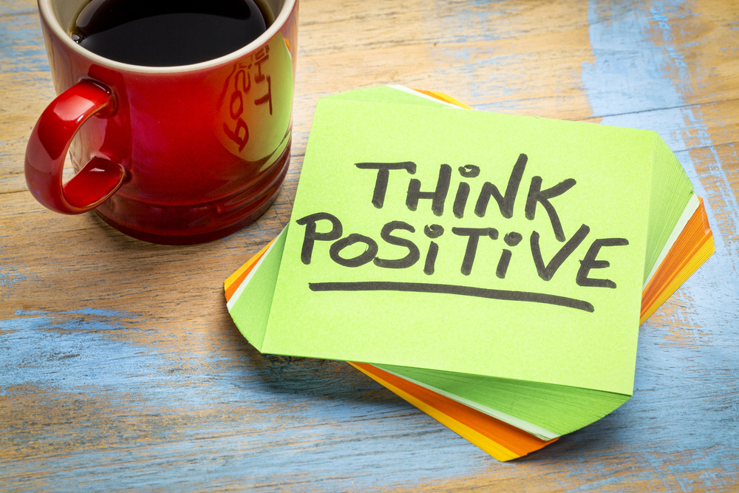

#6
Title
Explore Your Beliefs about the Meaning and Purpose of Life

Message
Have you ever thought about the meaning and purpose of your life? Exploring your beliefs can help you clarify what's most important to you and guide your actions accordingly. Take some time to reflect on what you truly value and what gives your life meaning. This could involve considering your spirituality, morality, or personal philosophy.

Once you have a clearer sense of your values and beliefs, you can use them as a foundation for setting goals and making choices that align with what matters most to you. This can help you feel more fulfilled and purposeful in your daily life.

Link

Image
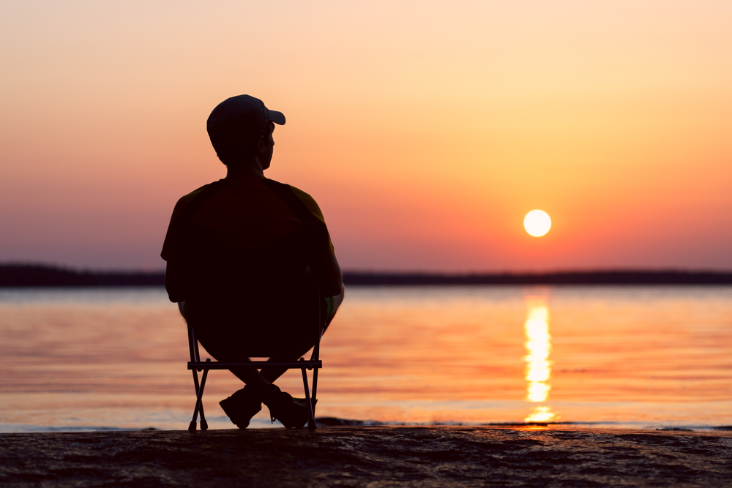

#7
Title
Tap into Social Connections and Community

Message
Social support can help reduce stress and improve overall well-being. Social connections and support can have a positive impact on mental health. Make time to connect with friends, family, or other supportive people in your life.

Stay connected with family and friends by scheduling regular check-ins or meetups. If you're unable to meet in person, consider scheduling a virtual chat or phone call.

Link

Image


#8
Title
10 Ways to Relax in Nature and Stress Less

Message
The way you spend time out in nature can affect how much your physical, emotional and mental health will benefit from it. If you're getting outside to relax, relieve stress or anxiety, focus your mind, or improve your health and well-being, try some of these tips to make it a more mindful experience.

Check out this link to know more about how to relax in nature and stress less.

Link
https://www.heart.org/en/healthy-living/healthy-lifestyle/stress-management/10-ways-to-relax-in-nature-and-stress-less

Image


#9
Title
Exercise Regularly

Message
Regular exercise is not only beneficial for physical health but also for mental well-being. Even just 30 minutes of walking a day can positively impact mood and reduce stress levels.

Exercise releases endorphins, which are natural mood boosters, and can also help to clear the mind and improve concentration. Additionally, exercise can provide a sense of accomplishment and self-confidence, leading to improved self-esteem. So, make sure to incorporate regular exercise into your daily routine for a happier and healthier life.

Link

Image
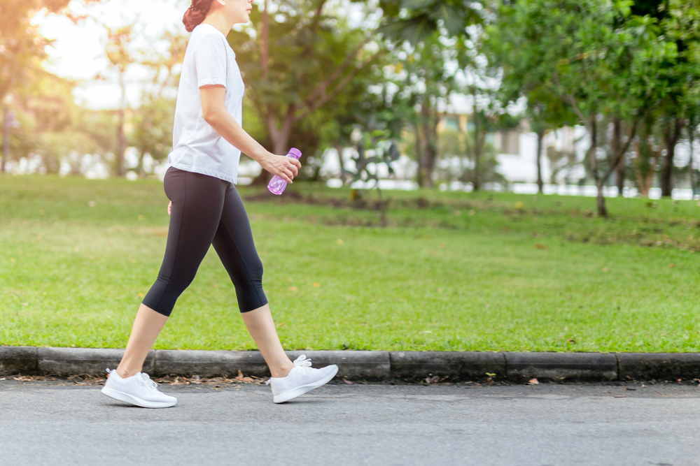

#10
Title
Get Quality Sleep

Message
To get better quality sleep:
1. Go to bed the same time each night and wake up the same time each morning.
2. Sleep in a dark, quiet, comfortable environment.
3. Exercise daily (but not right before bedtime).
4. Limit the use of electronics before bed.
5. Relax before bedtime. Try a warm bath or reading.
6. Avoid alcohol and large meals before bedtime.
7. Avoid stimulants like nicotine and caffeine.
8. Don't take naps after mid-afternoon. Keep naps short.
9. Try to get natural sunlight for at least 30 minutes a day.
10. Consult a health care professional if you have ongoing sleep problems.

Link
https://newsinhealth.nih.gov/2021/04/good-sleep-good-health

Image


#11
Title
Learn to Prioritize Your Tasks

Message
In today's fast-paced world, it's easy to feel overwhelmed by the never-ending list of tasks and responsibilities we face. To maintain our mental and physical health, it's essential to set priorities and manage our time effectively. Here are some tips to help you prioritize your tasks:

1. Make a list of all the tasks you need to accomplish.
2. Rank the tasks in order of importance, from most urgent to least urgent.
3. Assign a deadline for each task.
4. Break down large tasks into smaller, more manageable steps.
5. Learn to say "no" to requests that don't align with your priorities.
6. Focus on completing the most important tasks first.
7. Avoid multitasking and stay focused on one task at a time.
8. Take breaks and schedule time for self-care activities.

Remember, it's okay to ask for help and delegate tasks to others when necessary.

Link

Image
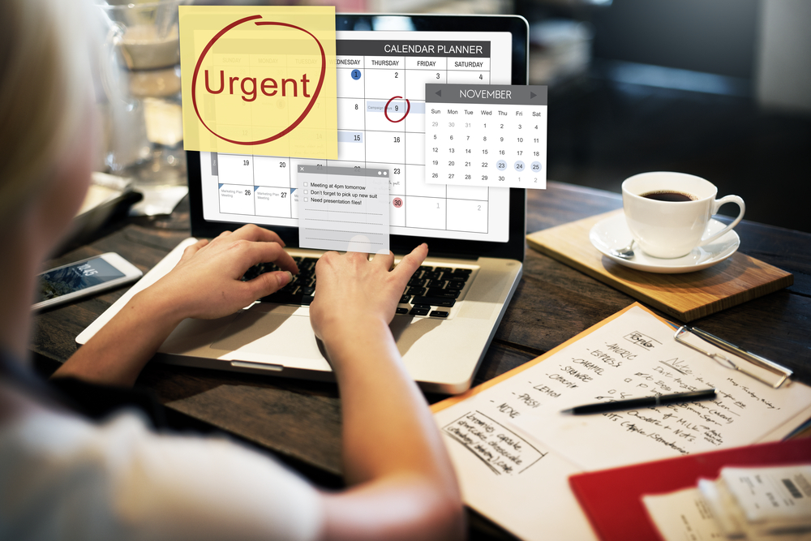

#12
Title
Practice Good Time Management

Message
Practicing good time management can lead to less stress and increased productivity. Here are some tips:

1. Prioritize tasks and create a to-do list.
2. Use a calendar or planner to schedule appointments and deadlines.
3. Break large tasks into smaller, more manageable tasks.
4. Avoid multitasking and focus on one task at a time.
5. Delegate tasks when possible.
6. Minimize distractions, such as social media and email notifications.

By effectively managing your time, you can accomplish more and feel less overwhelmed.

Link

Image


#13
Title
Show Compassion for Yourself

Message
Self-compassion is an important aspect of mental and emotional well-being. Instead of constantly focusing on our shortcomings, it's important to acknowledge our accomplishments and show ourselves some kindness.

At the end of each day, take a few moments to reflect on what you've accomplished, no matter how small it may seem. Did you make progress towards a goal? Did you complete a task that you've been putting off? Celebrate these achievements, and remember that even small steps forward are worth acknowledging.

When we show ourselves compassion, we create a positive and supportive environment for personal growth and change. So be kind to yourself, and give yourself credit for the progress you've made.

Link

Image


#14
Title
Schedule Regular Times for Meditation

Message
It's important to take time out of our busy lives to relax and recharge. Scheduling regular times for a relaxing activity that uses mindfulness and breathing exercises can help you manage stress and improve your overall well-being.

Meditation is a powerful tool for managing stress and improving overall wellbeing. It involves training the mind to focus on the present moment and let go of distracting thoughts.

Mayo Clinic offers an in-depth guide to meditation on their website. The guide covers everything from the basics of meditation to the different types of meditation techniques and their benefits. It also provides tips on how to get started with a regular meditation practice and how to make meditation a part of your daily routine. Check out the link for more information!

Link
https://www.mayoclinic.org/tests-procedures/meditation/in-depth/meditation/art-20045858

Image
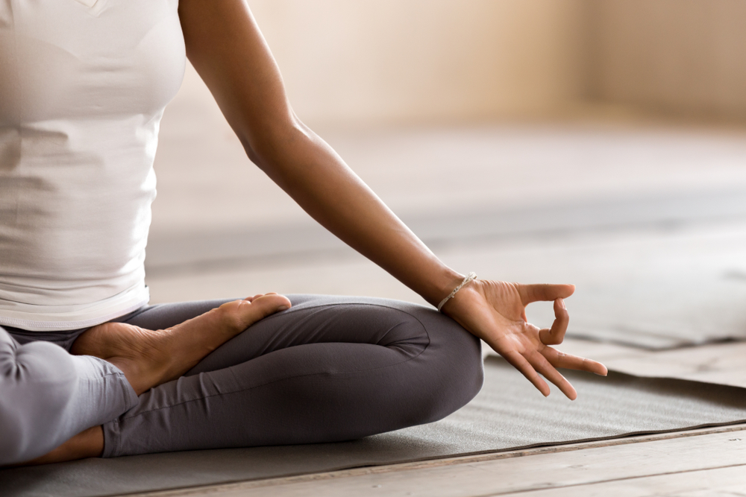

#15
Title
Strengthen Social Connections

Message
Social connections might help protect health and lengthen life. Scientists are finding that our links to others can have powerful effects on our health—both emotionally and physically.

To build healthy support systems:
1. Build strong relationships with your kids.
2. Get active and share good habits with family and friends.
3. If you’re a family caregiver, ask for help from others.
4. Join a group focused on a favorite hobby, such as reading, hiking, or painting.
5. Take a class to learn something new.
6. Volunteer for things you care about in your community, like a community garden, school, library, or place of worship.
7. Travel to different places and meet new people.

Link
https://www.nih.gov/health-information/social-wellness-toolkit

Image


#16
Title
Cope with Loss

Message
Learn healthy ways to help you through difficult times.

To help cope with loss:
1. Take care of yourself. Try to eat right, exercise, and get enough sleep. Avoid bad habits—like smoking or drinking alcohol—that can put your health at risk.
2. Talk to caring friends. Let others know when you want to talk.
3. Find a grief support group. It might help to talk with others who are also grieving.
4. Don’t make major changes right away. Wait a while before making big decisions like moving or changing jobs.
5. Talk to your doctor if you’re having trouble with everyday activities.
6. Consider additional support. Sometimes short-term talk therapy can help.
7. Be patient. Mourning takes time. It’s common to have roller-coaster emotions for a while.

Link
https://newsinhealth.nih.gov/2017/10/coping-grief

Image


#17
Title
Take Some Deep Breaths

Message
In the midst of a busy and stressful day, taking a few deep breaths can do wonders for your mental and physical health.

Simply inhale through your nose to a count of 4, hold for 1 second, and then exhale through your mouth to a count of 5. Repeat this exercise often and notice the calming effect it has on your mind and body.

It's a simple yet effective way to help reduce stress and promote relaxation. So next time you're feeling overwhelmed, take a few deep breaths and see how much better you feel.

Link

Image


#18
Title
Enjoy a Stroll

Message
Going for a walk can be a simple and effective way to practice mindfulness. As you walk, take the time to notice your breath and the world around you. Pay attention to the sights, sounds, and smells of your surroundings. As thoughts or worries enter your mind, acknowledge them without judgment, but then gently guide your attention back to the present moment.

Allow yourself to simply be in the moment and enjoy the experience of walking. You may find that as you become more mindful during your walks, you feel more relaxed, refreshed, and rejuvenated.

Link

Image
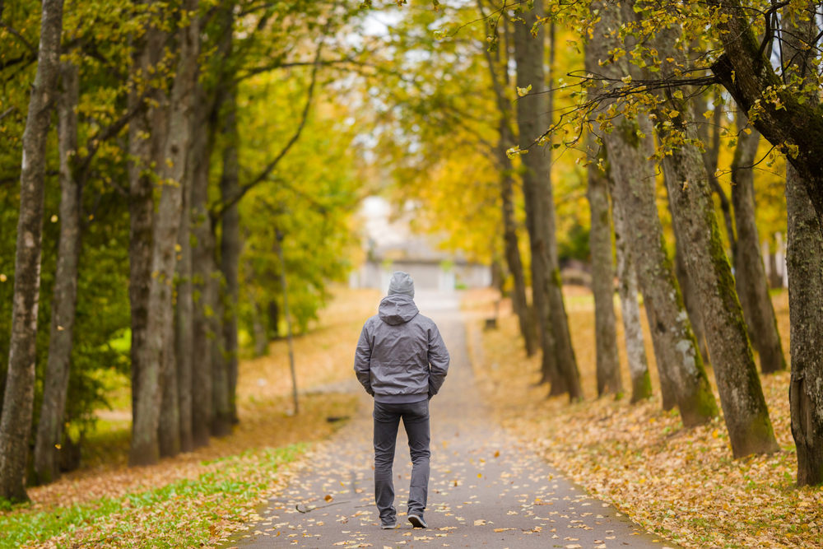

#19
Title
Practice Mindful Eating

Message
As part of our workplace fitness challenge, we want to share the benefits of mindful eating. Eating mindfully involves paying attention to hunger and fullness cues, savoring each bite, and eating slowly.

Here are some tips to help you eat mindfully:
1. Put down your phone or other distractions and focus on your food.
2. Chew your food slowly and savor each bite.
3. Pay attention to your body's signals of hunger and fullness.
4. Avoid eating while standing up or in front of a screen.
5. Take breaks between bites to help you slow down and enjoy your food.

Mindful eating can improve digestion, reduce stress, and promote weight loss. By eating mindfully, you can improve your overall health and wellness.

Link

Image
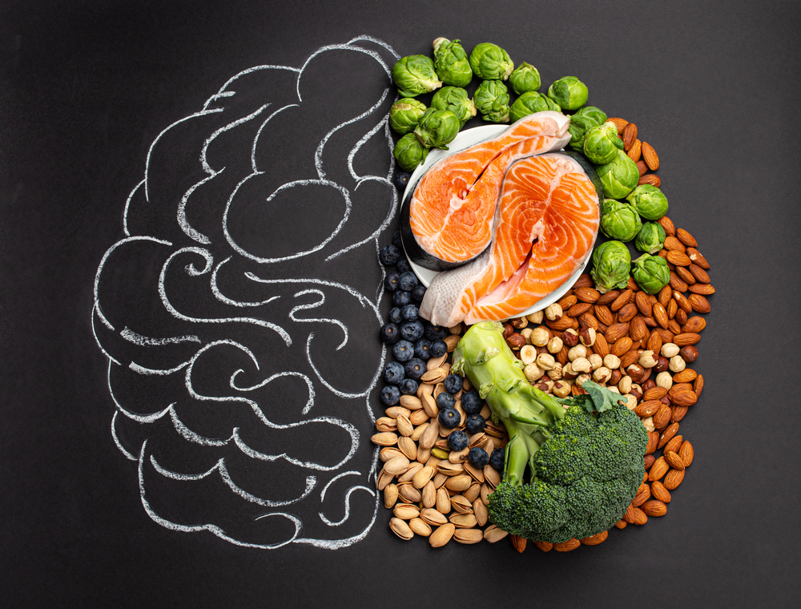

#20
Title
Be Aware of Your Body

Message
In today's fast-paced world, it can be easy to disconnect from our bodies and ignore our physical needs. However, taking the time to be aware of your body can have numerous benefits for your overall well-being.

One simple way to practice body awareness is to do a mental scan from head to toe. Take a few deep breaths and start at the top of your head. Notice any sensations, tension, or relaxation in your scalp, forehead, eyes, cheeks, jaw, and neck. Move down to your shoulders, arms, hands, chest, and abdomen. Then, focus on your lower back, hips, legs, feet, and toes.

As you scan each part of your body, try to simply observe any sensations without judgment. If you notice tension or discomfort, see if you can consciously release it with your breath or through gentle movement. This practice can help you tune in to your body's needs and take proactive steps to support your physical health.

Link

Image


#21
Title
7 Easy Ways to Be Mindful Every Day

Message
Do you find yourself getting lost in thought, worrying about the past or future? Practicing mindfulness can help you become more aware of the present moment and reduce stress and anxiety. Psych Central provides a guide to everyday mindfulness techniques, including focusing on your senses, breathing exercises, and body scanning. By incorporating mindfulness into your daily routine, you can cultivate a greater sense of calm and well-being.

Check out the link for more information and practical tips on how to get started.

Link
https://psychcentral.com/health/everyday-mindfulness#focus-on-senses

Image
