

Wellness Autopilot

Physical Wellness

#1
Title
Incorporating Movement into Your Daily Routine

Message
Sedentary behavior has been linked to many medical problems. Moving more and sitting less can have major health benefits. Experts recommend adults get at least 150 minutes (two and a half hours) of moderate physical activity a week. You can benefit from even a little activity at a time. Every minute counts when it comes to movement.

As part of our workplace fitness challenge, we want to encourage you to incorporate more movement into your daily routine. Even small amounts of physical activity can add up and improve your overall health and wellness.

Remember, every little bit helps! By making small changes to your daily routine, you can improve your physical and mental health.

Image


#2
Title
Incorporating Movement into Your Daily Routine

Message
Sedentary behavior has been linked to many medical problems. Moving more and sitting less can have major health benefits. Experts recommend adults get at least 150 minutes (two and a half hours) of moderate physical activity a week. You can benefit from even a little activity at a time. Every minute counts when it comes to movement.

As part of our workplace fitness challenge, we want to encourage you to incorporate more movement into your daily routine. Even small amounts of physical activity can add up and improve your overall health and wellness.

Remember, every little bit helps! By making small changes to your daily routine, you can improve your physical and mental health.

Link
https://www.heart.org/en/healthy-living/fitness/staying-motivated/set-your-fitness-goals

Image

#3
Title
Take the Stairs Instead of the Elevator

Message
Did you know that taking the stairs instead of the elevator is a great way to incorporate physical activity into your daily routine? Not only is it an easy way to get some exercise, but it also helps to improve your cardiovascular health and can even boost your mood.

Next time you're faced with the choice between the elevator and the stairs, challenge yourself to take the stairs instead. Start with just one flight and gradually work your way up to more. Your body will thank you!

Image


#4
Title
Park Your Car at the Far End of the Street or Parking Lot

Message
Did you know that parking your car at the far end of the street or parking lot can actually benefit your health? By walking those extra steps to and from your car, you're getting in some extra physical activity and burning more calories. Plus, it's a great way to squeeze in some exercise without even realizing it. So next time you're heading to work or running errands, challenge yourself to park a little farther away and enjoy the added health benefits!

Image


#5
Title
Set up Your Space so You Can Walk on a Treadmill While Watching TV or Stand When Using the Computer

Message
Are you looking for a way to be more active while working at your desk? Consider setting up a treadmill desk! With a treadmill desk, you can walk or jog at a slow pace while you work on your computer.

Here are some tips for setting up a treadmill desk:
1. Choose the right treadmill: Look for a treadmill that has a low maximum speed (1-2 miles per hour), a quiet motor, and a stable frame.

2. Position your desk: Make sure your desk is at the right height for your treadmill.

3. Start slowly: Begin by walking slowly (around 1 mile per hour) for short periods (10-15 minutes). Gradually increase the amount of time you spend on the treadmill, and slowly increase your speed over time.

4. Take breaks: Don't try to walk on the treadmill all day long. Take regular breaks to stretch, stand, or sit.

With these tips, you can set up a treadmill desk and start getting more physical activity into your workday. Remember, even small changes can make a big difference in your health!

Link
https://www.mayoclinic.org/healthy-lifestyle/adult-health/expert-answers/sitting/faq-20058005

Image


#6
Title
Try an Online Exercise Class to Stay Active from Home

Message
Staying active while staying home can be a challenge, but there are plenty of online exercise classes that can help you stay fit and healthy. Many fitness studios and gyms offer virtual classes that you can join from the comfort of your own home. From yoga to HIIT to dance, there's something for everyone. Plus, online classes can be a great way to stay motivated and accountable, as you can connect with other participants and instructors virtually. So why not give it a try? Find an online class that suits your interests and schedule, and get moving!

Image
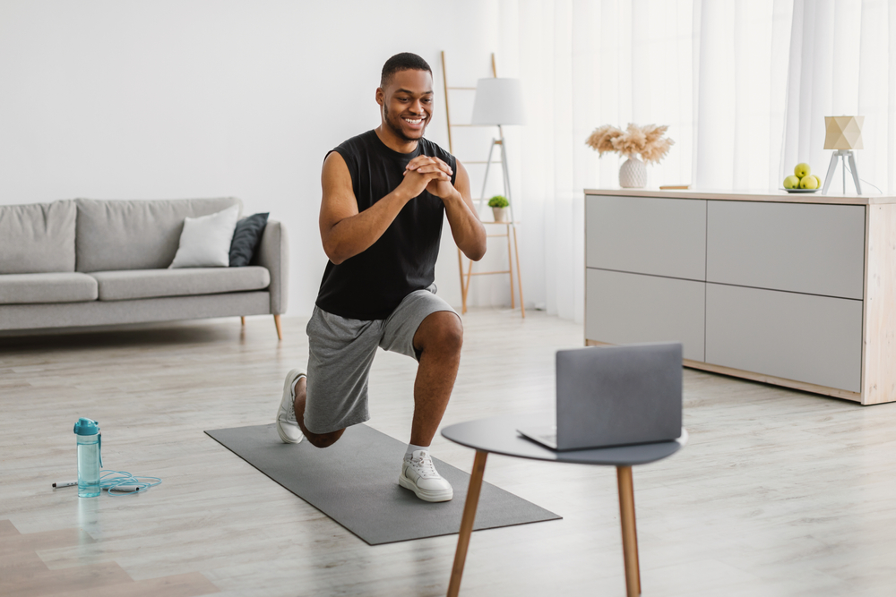

#7
Title
Set Hourly Alarms to Remind You to Move Around for a Minute or Two

Message
Are you sitting for long periods at work? Set an alarm on your phone or computer to go off every hour as a reminder to get up and move around for a minute or two. This will help improve circulation, reduce muscle tension, and keep you energized throughout the day.

Here is a link from Mayo Clinic that provides a multimedia resource on stretching exercises in the office.

Link
https://www.mayoclinic.org/healthy-lifestyle/adult-health/multimedia/stretching/sls-20076525

Image


#8
Title
Have Small Weights in Your Office or Around Your Home for Doing Arm Exercises

Message
We all know that incorporating regular strength exercises into our weekly routine is not just good for how we look, it also helps us stay active and functional in our day-to-day lives. Think of how essential muscle strenght is in things like carrying groceries, playing sports, doing housework and playing with your kids or grandkids.

Adding a set of small weights to your office or home can make it easier to incorporate strength exercises into your daily routine. Consider doing bicep curls or tricep extensions during a quick break or while on a conference call. It's a simple way to keep to not just keep your arms toned but also to build and maintain strength so you can stay active throughout your life.

Image


#9
Title
Take a Walk on Your Lunch Breaks

Message
Are you tired of sitting at your desk all day? Try taking a walk on your lunch breaks or having walking meetings with your colleagues. Not only will it help you get some exercise, but it can also boost your creativity and productivity. Walking can help clear your mind and give you a fresh perspective, making you more alert and focused when you return to work. So, grab a colleague and take a walk today!

Link
https://www.youtube.com/@EveryBodyWalk/about

Image


#10
Title
Know How Many Calories You Need for Your Weight Goals

Message
Whether you aim to lose, maintain, or gain weight, consuming the right amount of food for your body and goals is crucial. Ideally, we'd intuitively know when to start and stop eating (Google: ""Mindful Eating""), but most of us need help determining our ideal intake. A daily calorie budget can be helpful.

Individual needs vary, and a one-size-fits-all approach isn't effective. Your caloric needs depend on factors like age, sex, height, weight, exercise levels, and goals. Fortunately, it's easy to calculate your personalized budget using the right tools. Check out the NIDDK Bodyweight Planner (linked below), the most advanced tool for personalizing a daily calorie budget.

By understanding your daily caloric needs, you can ensure you're fueling your body properly for daily activities. Striking the right balance and recognizing your personal needs will help you achieve weight goals and maintain a healthy lifestyle!

Link
https://www.niddk.nih.gov/bwp

Image


#11
Title
Record Your Daily Food Intake and Physical Activity Using Pacer

Message
Keeping track of your daily food intake and physical activity can be a great way to stay on track with your health goals. One easy way to do this is by using Pacer or keeping a journal. By recording what you eat and how much you exercise, you can get a better understanding of your habits and make changes where needed. Some apps even offer personalized recommendations based on your goals and progress. So whether you prefer a high-tech approach or a pen and paper, start tracking today and see the positive changes it can bring to your health and fitness journey.

The Pacer Coach feature includes a food journaling feature which helps you record what and when you eat, as well as how you were feeling and your hungerness levels. You can also log your weight, calculate your daily calorie burn, and track your progress more effectively.

Image
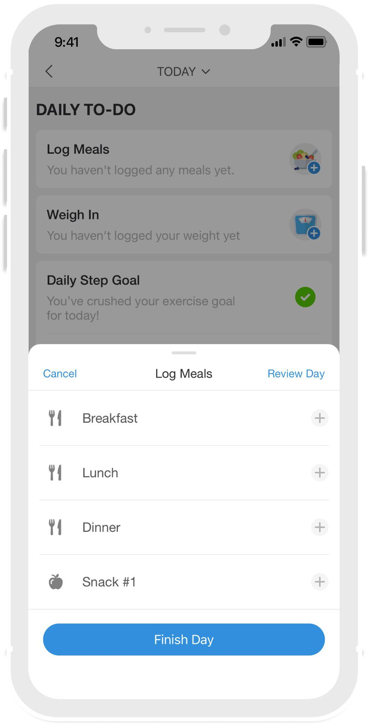

#12
Title
How to Cut Excess Calories for a Healthier Lifestyle

Message
If you're looking to lose weight or maintain a healthy weight, reducing calories can be a key factor in achieving your goals. Here are some tips for trimming some excess calories from your diet:

1. Monitor portion sizes and stick to appropriate serving sizes.

2. Swap high-calorie foods for lower calorie options. For example, try switching from full-fat dairy products to low-fat or fat-free versions.

3. Limit your intake of added sugars, saturated fats, and sodium.

4. Choose foods that are high in fiber and protein to help you feel full and satisfied.

5. Be mindful of liquid calories from sugary drinks, alcohol, and high-calorie coffee drinks.

Remember, cutting calories doesn't mean you have to sacrifice taste or nutrition. Get creative in the kitchen and try new healthy recipes to make your meals satisfying and enjoyable while keeping your calorie intake in check.

Link
https://www.cdc.gov/healthyweight/healthy_eating/cutting_calories.html

Image


#13
Title
The Benefits of Weighing Yourself Regularly

Message
While weighing yourself every day isn't necessary or recommended for everyone, it can be helpful for some people in maintaining a healthy weight. By weighing yourself regularly, you can track your progress and make adjustments to your diet and exercise routine as needed. However, it's important to keep in mind that weight can fluctuate day to day due to factors such as hydration levels and menstrual cycles, so it's important to not get too caught up in the numbers. If weighing yourself every day causes stress or anxiety, it may be better to weigh yourself once a week or focus on other markers of progress such as how your clothes fit or how you feel overall.

Image
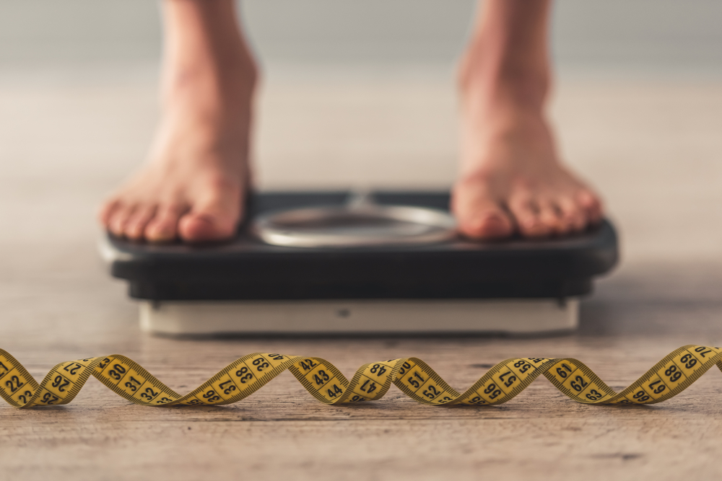

#14
Title
Set Specific Goals to Achieve Your Healthy Weight Goals

Message
Setting specific goals can be a great way to achieve a healthy weight. However, it's important to be realistic about your expectations. Here are some tips to help you set achievable goals:

1. Set realistic targets: Aim for a healthy and sustainable rate of change. For weight loss, typically around 1-2 pounds per week is the range you should target.

2. Be specific: Instead of setting a vague goal like ""lose weight,"" set a specific goal like ""lose 8 pounds in 2 months."" This will give you a clear target to work towards.

3. Make a plan: Decide on the steps you'll take to achieve your goal, such as eating healthier, exercising more, or tracking your food intake.

4. Track your progress: Keep a record of your progress, such as weighing yourself regularly or taking measurements.

Remember, achieving and maintaining your healthy weight is a journey, and it's important to be kind to yourself along the way. Celebrate your successes and learn from your setbacks to help you reach your goals.

Image
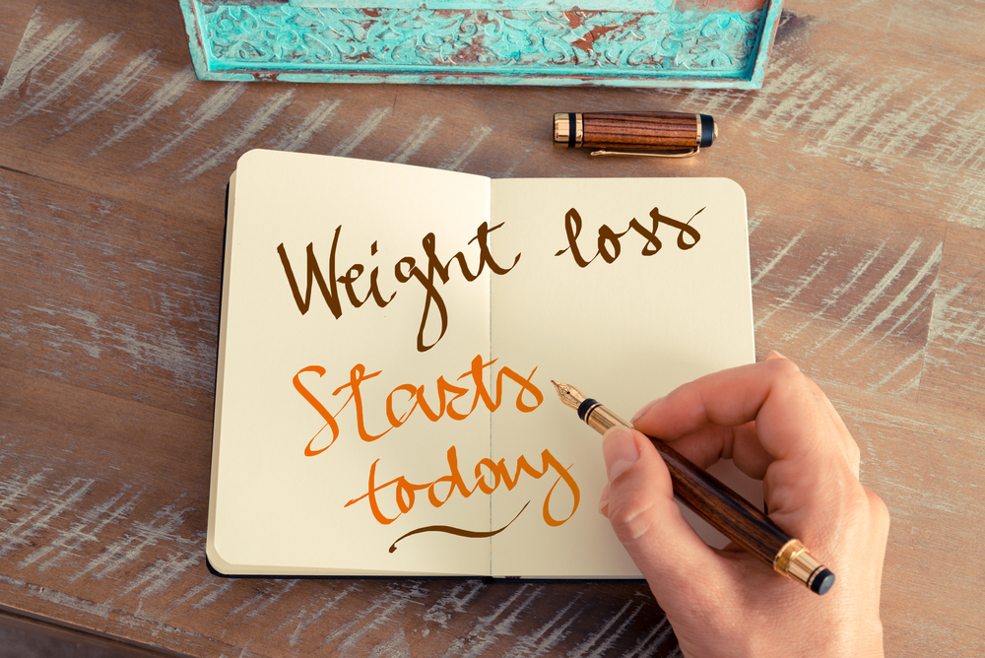

#15
Title
Choose Healthy Meals and Physical Activities You Enjoy

Message
Eating healthy and staying active are important for overall health and well-being. However, it can be difficult to maintain a healthy lifestyle if you don't enjoy the foods you're eating or the activities you're doing. That's why it's important to choose healthy meals and physical activities that you enjoy.

When it comes to meals, focus on incorporating a variety of whole foods such as fruits, vegetables, whole grains, and lean proteins. Experiment with different recipes and cooking methods to find what you like best. Don't restrict yourself too much or eliminate entire food groups, as this can lead to feelings of deprivation and overeating.

As for physical activities, choose ones that you find fun and enjoyable. It could be anything from dancing to hiking to playing sports. You'll be more likely to stick with it if it doesn't feel like a chore. If you're new to exercise, start small and gradually increase your intensity and duration over time.

Image
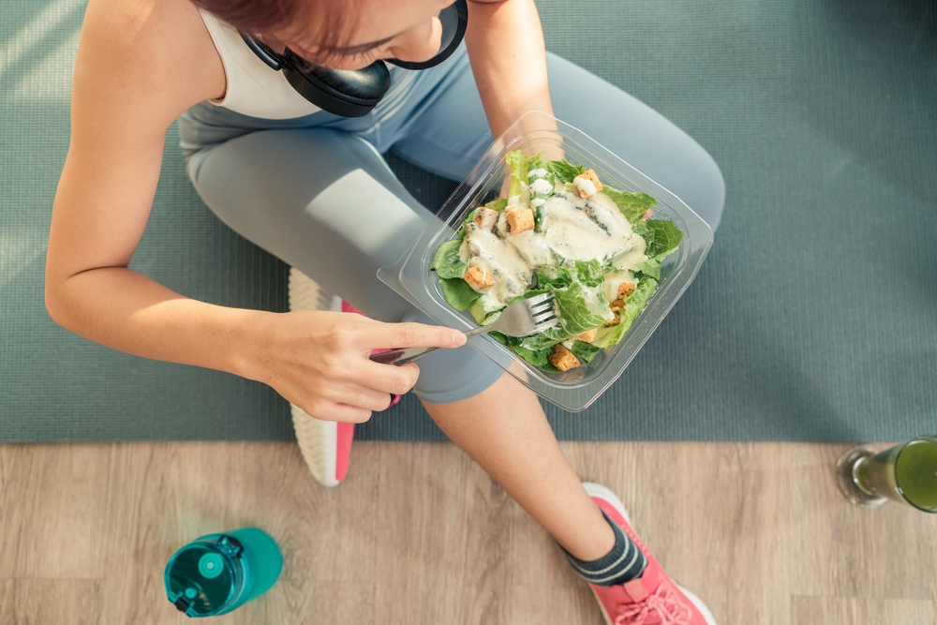

#16
Title
Eating Healthier While Eating Out

Message
You work so hard to eat healthy at home, but what do you do when it's time for lunch with coworkers or dinner with friends? Eating healthy when eating out, especially socially, can be challenging. With a few simple tips, however, you can make healthier choices that support your wellness goals.

Here are some tips to keep in mind when eating out:
1. Opt for grilled or baked options instead of fried foods
2. Skip high-calorie condiments, such as mayonnaise and salad dressing
3. Choose a smaller portion size or share a dish with a friend
4. Ask for steamed or roasted vegetables instead of french fries or other high-fat side dishes
5. Plan ahead by researching restaurant menus and making healthier choices before arriving

By making healthier food choices when eating out, you can support your wellness goals and feel great!

Image


#17
Title
How to Use Fruits and Vegetables to Help Manage Your Weight

Message
Eating a variety of fruits and vegetables is an essential part of a healthy diet. They are low in calories and packed with essential vitamins, minerals, and fiber that can help reduce the risk of chronic diseases like obesity, heart disease, and some cancers.

1. Aim for at least 2.5 cups of vegetables and 2 cups of fruit each day.
2. Try incorporating a variety of colors and textures to keep meals interesting.
3. Fresh, frozen, or canned options are all great choices as long as they are prepared without added sugars or sauces.
4. Snack on fruits and veggies throughout the day to help curb hunger and add extra nutrients to your diet.

Remember, every little bit counts!

Link
https://www.cdc.gov/healthyweight/healthy_eating/fruits_vegetables.html

Image


#18
Title
Plan Physical Activities with Friends or Family

Message
Social support can be a great motivator when it comes to being physically active. One way to make sure you're staying active is to plan physical activities with friends or family. This can be anything from going for a hike, playing a game of basketball, or taking a yoga class together. Not only will it help you stay accountable to your fitness goals, but it can also be a fun way to spend time with loved ones. Plus, having someone to share the experience with can make it more enjoyable and rewarding. So, the next time you're planning a get-together, consider adding some physical activity to the agenda!

Image


#19
Title
Identify Temptations, Plan Ways to Stay on Track

Message
If you're trying to make healthy lifestyle changes, it's important to identify your temptations and plan ways to avoid or overcome them. Whether it's your favorite junk food or skipping workouts to binge-watch TV, knowing your weaknesses can help you stay on track. Try writing down a list of your temptations and brainstorming ways to avoid or limit them.

For example, if you can't resist the urge to snack on chips, try replacing them with healthier options like air-popped popcorn or veggies and hummus. If you struggle to find time to exercise, plan your workouts with a friend or family member to make them more enjoyable and hold yourself accountable. Remember, small changes can lead to big results, so stay motivated and focused on your goals!

Image


#20
Title
Learn from Your Slips

Message
Sticking to a healthy eating and physical activity plan can be challenging, and slips are bound to happen. The important thing is to not let those slips derail your progress. Instead, take the opportunity to learn from them. Identify what triggered the slip and plan ways to avoid it in the future.

Was it a stressful day at work? Maybe try incorporating stress-reducing activities like yoga or meditation into your routine.
Did you give in to a tempting dessert? Plan ways to satisfy your sweet tooth with healthier options.

Remember, slips are a natural part of the process, so don't beat yourself up about it. Use them as a learning opportunity and restart your plan with renewed motivation.

Image
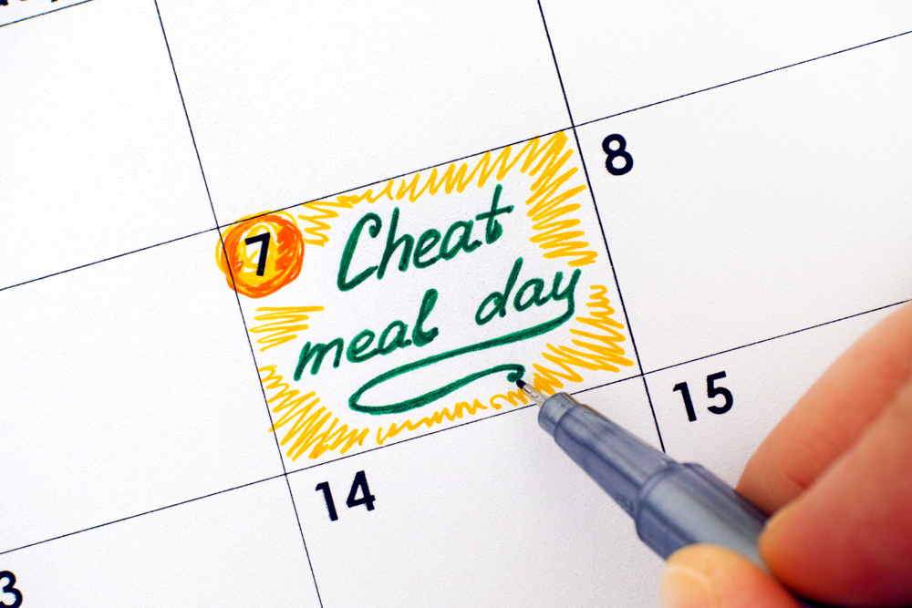

#21
Title
Be Patient, Changing Lifestyle Habits Takes Time

Message
Making positive changes to your lifestyle can be a challenging and ongoing process. It's important to remember that it takes time to develop new habits and to see the results you want. Don't get discouraged if you don't see progress right away. Instead, focus on making small, sustainable changes and celebrating your successes along the way. Remember that every healthy choice you make is a step in the right direction, and with time and patience, you can achieve your goals and live a happier, healthier life.

Image


#22
Title
Eat a Variety of Foods

Message
The National Institute of Health recommends that we Plan our Plate with the right mix of nutrients to help us feel energized and satisfied. Fill half your plate with fruits and vegetables, a quarter with whole grains, and a quarter with lean protein. Incorporating healthy fats, such as olive oil or nuts, can also help keep you feeling full and satisfied. And don't forget to stay hydrated by drinking plenty of water throughout the day.

Link
https://newsinhealth.nih.gov/special-issues/eating/plan-your-plate

Image


#23
Title
Limit Foods that are Low in Vitamins and Minerals

Message
Eating a variety of nutrient-dense foods is essential for good health. To ensure that your body is getting all the necessary vitamins and minerals, it's important to limit foods that are low in nutrients. This includes highly processed foods, sugary drinks, and foods high in saturated and trans fats. Instead, focus on incorporating more whole foods, such as fruits, vegetables, whole grains, lean proteins, and healthy fats into your diet. These foods are packed with essential vitamins and minerals that your body needs to function properly. For more information on how to plan a healthy and balanced diet, check out the USDA's MyPlate guidelines.

Link
https://www.myplate.gov/

Image


#24
Title
Cut Down on Sugar

Message
Consuming too much sugar can lead to weight gain, tooth decay, and other health problems. Cutting down on sugar can be challenging, but there are some simple steps you can take. Start by picking foods with little or no added sugar, such as fresh fruits, vegetables, and whole grains.

When choosing packaged foods, read the Nutrition Facts label and look for products with less total sugar. Keep in mind that sugar can hide in unexpected places, such as sauces, condiments, and even some types of bread. By making small changes to your diet, you can reduce your sugar intake and improve your overall health.

Link
https://newsinhealth.nih.gov/special-issues/eating/sweet-stuff

Image


#25
Title
Replace Saturated Fats in Your Diet with Unsaturated Fats

Message
Eating a healthy diet doesn't mean you have to give up all fats. However, it's important to choose the right types of fats. Saturated fats found in butter, meat fats, and shortening can raise your cholesterol levels and increase your risk of heart disease.

Instead, try to replace these fats with healthier options like olive, canola, or other vegetable oils. These oils are rich in unsaturated fats that can help lower your cholesterol levels and reduce your risk of heart disease. So, next time you're cooking, try swapping out butter for olive oil or using canola oil in your salad dressings. Small changes like these can make a big difference in your overall health!

Link
https://newsinhealth.nih.gov/special-issues/eating/skinny-fat

#26
Title
Increase Your Fiber Intake Gradually, so Your Body Can Get Used to it

Message
Getting more fiber in your diet is important for your overall health. Fiber can help lower your cholesterol, control your blood sugar, and keep you feeling full longer. It's recommended that adults get at least 25-38 grams of fiber per day. To increase your fiber intake, start by adding more fruits, vegetables, and whole grains to your diet. Try swapping out white bread and pasta for whole grain options, or snack on fresh fruit or vegetables instead of processed snacks. It's important to increase your fiber intake gradually, as too much too soon can cause digestive discomfort. Drinking plenty of water can also help with digestion and make it easier to increase your fiber intake.

Link
https://newsinhealth.nih.gov/special-issues/eating/rough-up-your-diet

#27
Title
Choose Complex Carbs for a Healthier Diet

Message
Not all carbohydrates are created equal. Opting for complex carbs over simple carbs can have numerous benefits for your health. Counting carbs can help you maintain a balanced diet and manage your weight effectively. Here are some tips based on the NIH's guidelines:

1. Understand carb types: Choose complex carbs found in whole grains, legumes, and vegetables, which provide sustained energy and essential nutrients.
2. Know your daily carb needs: The recommended daily carbohydrate intake depends on factors like age, sex, weight, and activity level. Generally, carbs should make up 45-65% of your total daily caloric intake.
3. Read food labels: Check nutrition labels to understand the carb content in packaged foods. Look for whole grain and high-fiber options and be mindful of added sugars.
4. Portion control: Be aware of portion sizes when consuming carb-rich foods.
5. Balance your meals: Create well-rounded meals by combining carbs with lean proteins and healthy fats.

Link
https://newsinhealth.nih.gov/2012/12/counting-carbs

#28
Title
Watch out for Foods High in Salt

Message
Too much salt in your diet is linked to a host of health problems, the most well-known is high blood pressure. And most of the salt we consume is not what we add from the shaker, it's already in the foods we eat.

Use fresh poultry, fish, and lean meat, rather than canned, smoked, or processed. Choose fresh or frozen vegetables that have no added salt and foods that have less than 5% of the Daily Value of sodium per serving. Rinse canned foods.

Link
https://newsinhealth.nih.gov/special-issues/eating/salty-stuff

#29
Title
Stay Hydrated!

Message
Drinking enough water is important for overall health and can help prevent headaches, fatigue, and other health issues. Drink at least 8-10 glasses of water a day.

1. Drink water before you get thirsty: Thirst is a sign that you're already starting to get dehydrated. Make sure to drink water regularly throughout the day, even if you don't feel thirsty.
2. Monitor your urine: Pay attention to the color of your urine. If it's dark yellow or amber in color, you're likely not drinking enough water.
3. Drink water with meals: Drinking water with your meals can help ensure you're getting enough fluids throughout the day.
4. Carry a water bottle: Make it easy to drink more water by carrying a water bottle with you wherever you go. This will help you stay hydrated on-the-go and remind you to drink more water.

#30
Title
Quench Your Thirst the Healthy Way: Choose Water and Healthier Drinks

Message
Drinking water and other healthier beverages can do wonders for your overall health and well-being. Here are some tips for making sure you stay hydrated the healthy way:

1. Choose water: Drinking water is essential for good health. It helps keep your body hydrated, promotes digestion, and flushes out toxins. Make it a habit to carry a reusable water bottle with you wherever you go.

2. Avoid sugary drinks: Soda, energy drinks, and sports drinks are high in sugar and can lead to weight gain, tooth decay, and other health problems. Instead, choose unsweetened drinks like water, unsweetened tea, or sparkling water.

3. Limit alcoholic beverages: Drinking too much alcohol can lead to dehydration, liver damage, and other health problems.

4. Try flavored water: If you're looking for a little flavor, try infusing your water with fresh fruit or herbs like mint, basil, or lemon. You can also try unsweetened flavored water or herbal tea.

Link
https://www.cdc.gov/healthyweight/healthy_eating/water-and-healthier-drinks.html

