Wellness Autopilot

Challenge Notifications

Challenge Notifications
The day before your challenge starts

Title
Challenge starts tomorrow!

Message
We are excited to announce that our challenge starts tomorrow. 📣 This is your chance to kickstart your fitness journey and make positive changes towards a healthier lifestyle. The challenge starts at midnight (00:00) in your time zone.

Remember, small steps lead to big changes. Make sure to track your progress and celebrate your accomplishments along the way. You should open Pacer regularly (once a day) and your wearable if you are syncing it with Pacer.

We wish you all the best of luck and can't wait to see the amazing results you achieve! 💪🏃‍♀️💪🏃‍♂️

Image

The first day of your challenge

Title
Challenge starts today!

Message
Welcome to the first day of our challenge! 🎊 We're so excited to have you on board as we work towards a healthier, more active lifestyle together. Today marks the beginning of a fantastic journey, and we can't wait to see our progress during the challenge period.

Remember to sync your activity data frequently (we recommend once daily) to track your progress accurately. 📱 Don't hesitate to reach out if you need any assistance along the way.

Let's get moving and make this challenge a huge success! 💪🏃‍♀️💪🏃‍♂️

Image
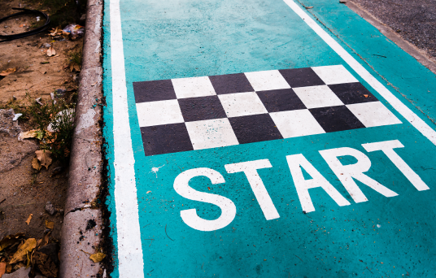

Halfway through your challenge

Title
Halfway through the journey!

Message
We've reached the halfway mark of our challenge! 🎉 What a journey it's been so far. The dedication and hard work shown by each and every one of you is truly inspiring.

It's important to take a moment to celebrate our progress and reflect on how far we've come. Let's keep pushing forward and remain committed to our goals. We've got this! 💪🏃‍♀️💪🏃‍♂️

Image

The last day of your challenge

Title
Last day of the challenge!

Message
"Today marks the final day of our challenge! 🔚 What a journey it's been! 🎊 Over the past few weeks, we've pushed ourselves, celebrated our progress, and built a community of support. The challenge will end at 11:59:59 PM today in your time zone.

Thank you to each and every one of you for your dedication and hard work. We couldn't have done it without you! 💪🏃‍♀️💪🏃‍♂️

Don't forget to open the app and sync your data before 12:00 noon tomorrow. After the deadline, no more data will be considered for this challenge."

Image
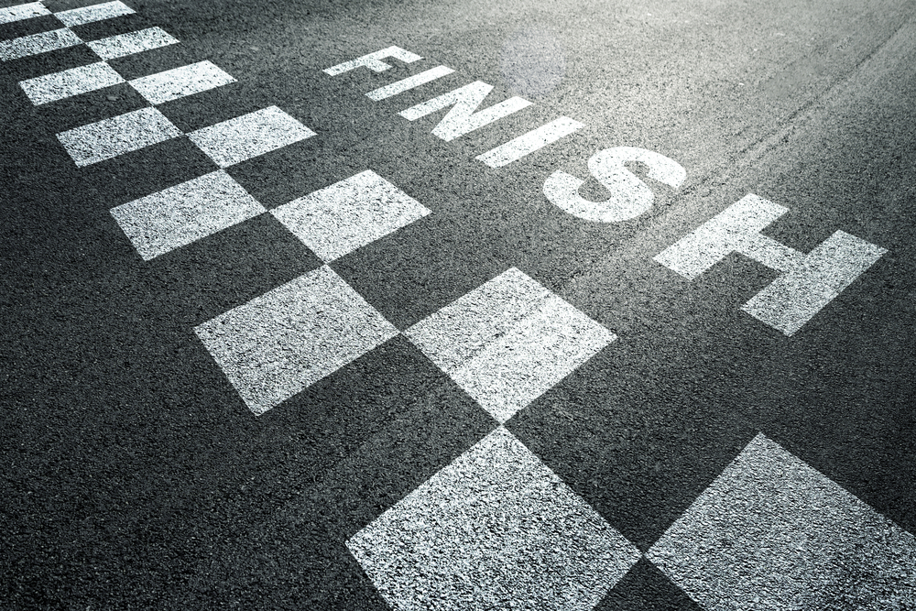

The day after your challenge ends (before 12:00 noon)

Title
Don’t forget to sync your data!

Message
"Just a friendly reminder! Our challenge data sync deadline is quickly approaching. To make sure that your progress is accurately recorded and counted towards your final scores, please open Pacer on your phone 📲 and sync your data before 12:00 noon today. This includes any wearables you have synced with Pacer.

Don't miss out on the opportunity to show off your progress and be recognized for all of your hard work. Sync now and let's make this the best challenge yet! 💪🏃‍♀️💪🏃‍♂️"

Image
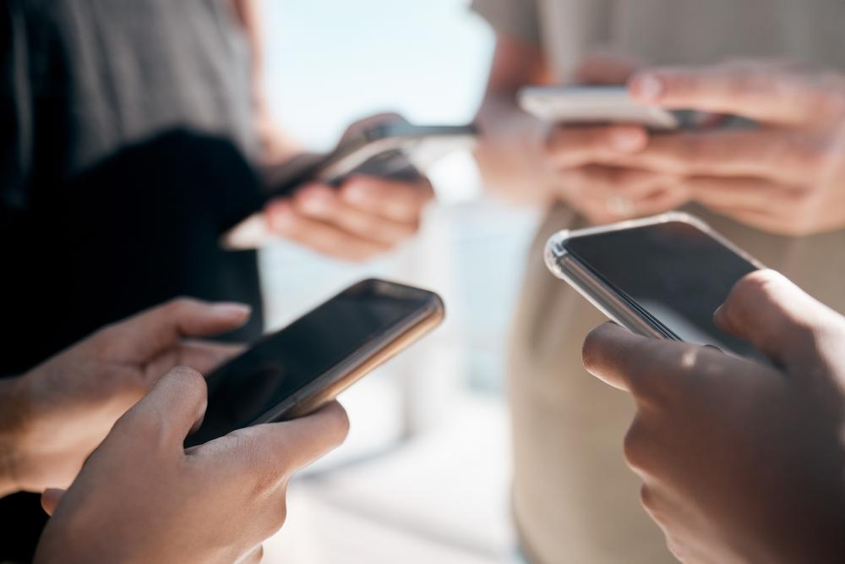

2 days after your challenge ends

Title
Congratulations! Let’s check your challenge results!

Message
"The moment we've all been waiting for has arrived! The final results of our challenge are in and it's time to celebrate our hard work and dedication.

We've achieved incredible things together and pushed ourselves to be our best selves. Whether we've exceeded our initial goals or are still working towards them, every step we've taken has brought us closer to a healthier, more active lifestyle.

Let's give a round of applause to each and every one of you for your hard work and dedication. Together, we've made a positive impact on our health and well-being. 🎉💪🏃‍♀️💪🏃‍♂️"

Image

